Name Period

What is in that window
It is now time to look at how type is use, so look closely and discover the wonderful world of typography.

Task: Label and mark each example with the following terms below:
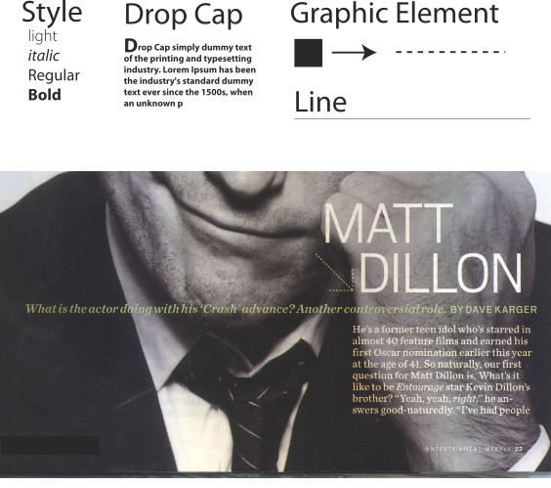
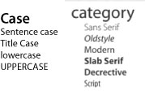
Example 2
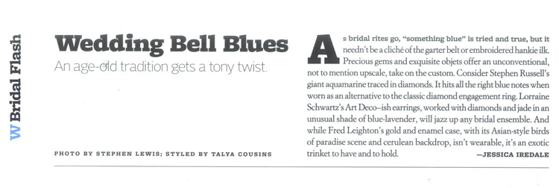

Example 3 (from a magazine)

